Sunday | Monday | Tuesday | Wednesday | Thursday | Friday | Saturday
31 | 1 | 2 | 3 | 4 | 5 | 6
Easter Service Outdoors:  10 -11 a.m.  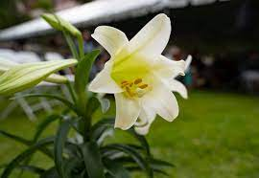  Easter Brunch  Happy Birthday,  Linda Horner | Senior Cafe:  11 – 1 M- F  Performing Arts Studio 3:30 -6:30  Cadette Tr 1214  6:30 – 8:15 | Senior Cafe:  11 – 1 M- F  Performing Arts Studio 3:30 -6:30  Cadette Troop 61230 6:30 – 8:15  Happy Birthday,  Jackie Groeneveld | Senior Cafe:  11 – 1 M- F  Performing Arts Studio 3:30 -6:30 | Senior Cafe:  11 – 1 M- F  Performing Arts Studio 3:30 -6:30 | Senior Cafe:  11 – 1 M- F | PetWalk for SPCA  See Teresa Hehemann  Performing Arts Studio  12 - 6
7 | 8 | 9 | 10 | 11 | 12 | 13
Worship Service:  10 -11 a.m.  Bible Study in Room 4  after service  Visitation to Shut Ins | Senior Cafe:  11 – 1 M- F  Performing Arts Studio 3:30 -6:30  Cadette Tr. 1227  6:30 – 8:15 | Senior Cafe:  11 – 1 M- F  Performing Arts Studio 3:30 -6:30 | Senior Cafe:  11 – 1 M- F  Performing Arts Studio 3:30 -6:30 | Senior Cafe:  11 – 1 M- F  Performing Arts Studio 3:30 -6:30 | Senior Cafe:  11 – 1 M- F  Performing Arts Studio 4:30 - 6:30 | Tr. 1278 10 – 12  Performing Arts Studio 12 - 5
14 | 15 | 16 | 17 | 18 | 19 | 20
Worship Service:  10 -11 a.m.  Bible Study in Room 4  after service | Senior Cafe:  11 – 1 M- F  Blanket Workshop 9 - 11  Performing Arts Studio 3:30 -6:30  6 PM Session  Troop 1214 6:30 – 8:15 | Senior Cafe:  11 – 1 M- F  Performing Arts Studio 3:30 -6:30  Cadette Troop 61230 6:30 – 8:15 | Senior Cafe:  11 – 1 M- F  Performing Arts Studio 3:30 -6:30 | Senior Cafe:  11 – 1 M- F  Performing Arts Studio 3:30 -6:30  8:30 – 10:30 TOPS | Senior Cafe:  11 – 1 M- F
21 | 22 | 23 | 24 | 25 | 26 | 27
Worship Service:  10 -11 a.m.    Happy Birthday,  Clarence Faucett | Senior Cafe:  11 – 1 M- F  Performing Arts Studio 3:30 -6:30  Troop 1227 6:30 – 8:15  Happy Birthdays,  Andrew Davis  Gordon Ollsen | Senior Cafe:  11 – 1 M- F  Performing Arts Studio 3:30 -6:30  Cadette Troop 61230 6:30 – 8:15 | Senior Cafe:  11 – 1 M- F  Performing Arts Studio 3:30 -6:30 | Senior Cafe:  11 – 1 M- F  Performing Arts Studio 3:30 -6:30 | Senior Cafe:  11 – 1 M- F | Tr. 1278 10 – 12  Performing Arts Studio 12 - 5  Happy Birthdays,  Mariela Ollsen  Steve Anderson  Teresa Hehemann
28 | 29 | 30 | 1 | 2 | 3 | 4
Worship Service:  10 -11 a.m.  Bible Study in Room 4  after service | Senior Cafe:  11 – 1 M- F  Performing Arts Studio 3:30 -6:30 | Senior Cafe:  11 – 1 M- F  Performing Arts Studio 3:30 -6:30 | Senior Cafe:  11 – 1 M- F  Performing Arts Studio 3:30 -6:30 | Senior Cafe:  11 – 1 M- F  Performing Arts Studio 3:30 -6:30 | Senior Cafe:  11 – 1 M- F

2nd  Jackie Groeneveld  5681 92nd Terrace N  Pinellas Park, Florida 33782  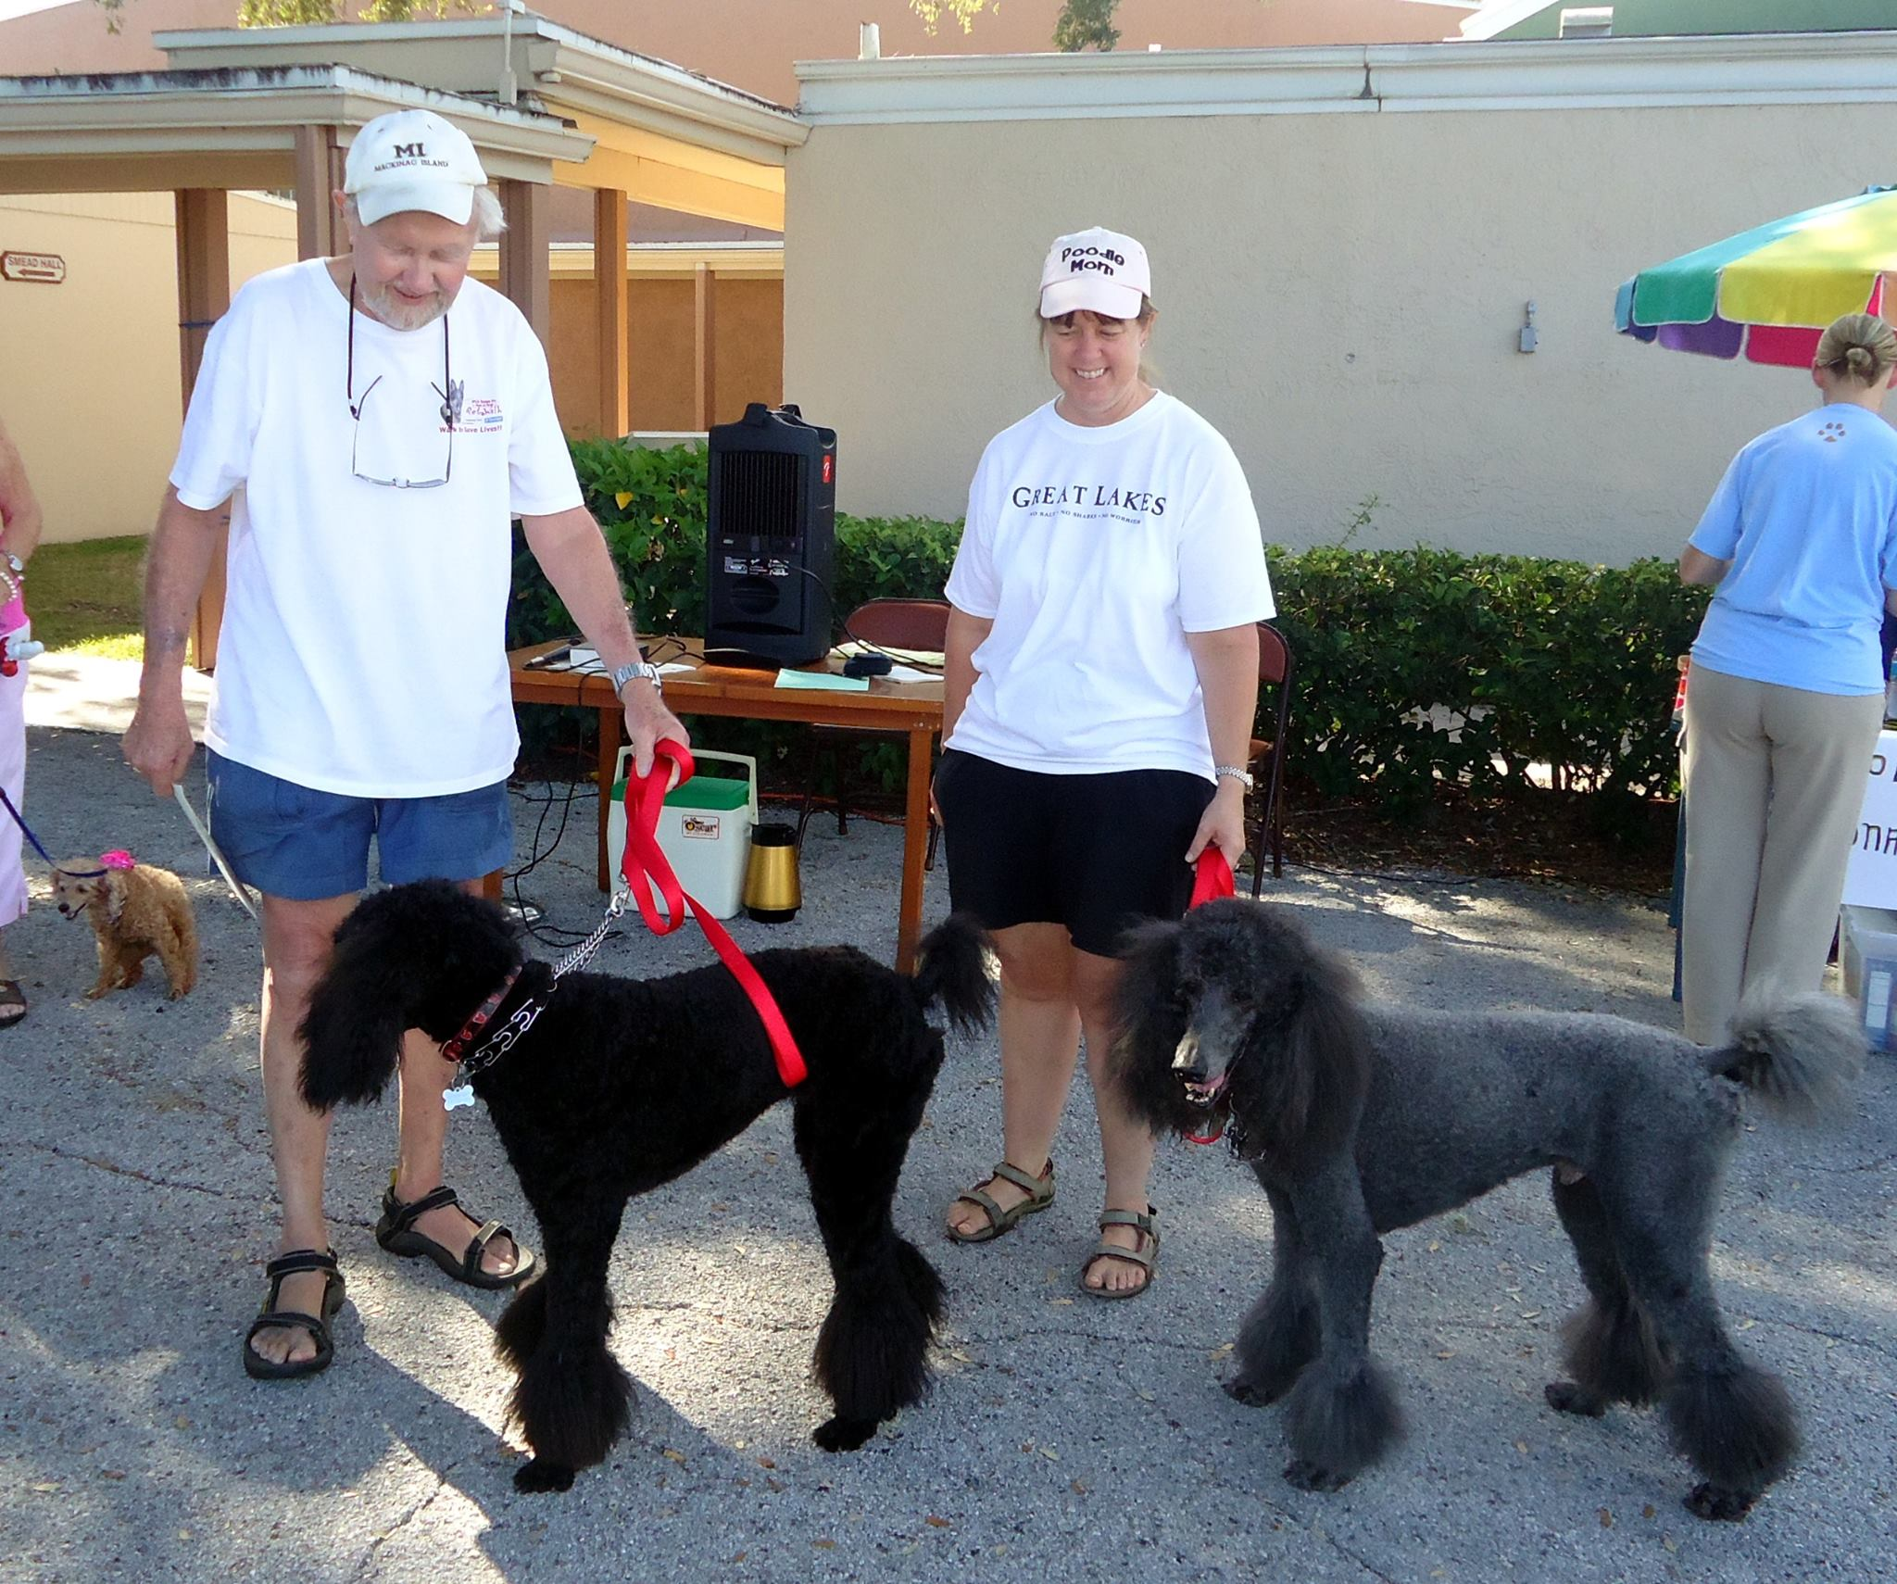 | 21st  Clarence Faucett  11211 101 Way N.  Largo, Florida 33773  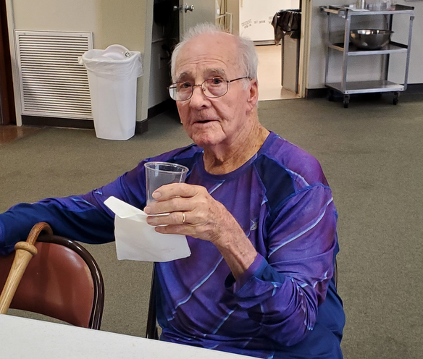 | 22nd  Andrew Davis  11093 86th Ave. N  Seminole, Florida 33772  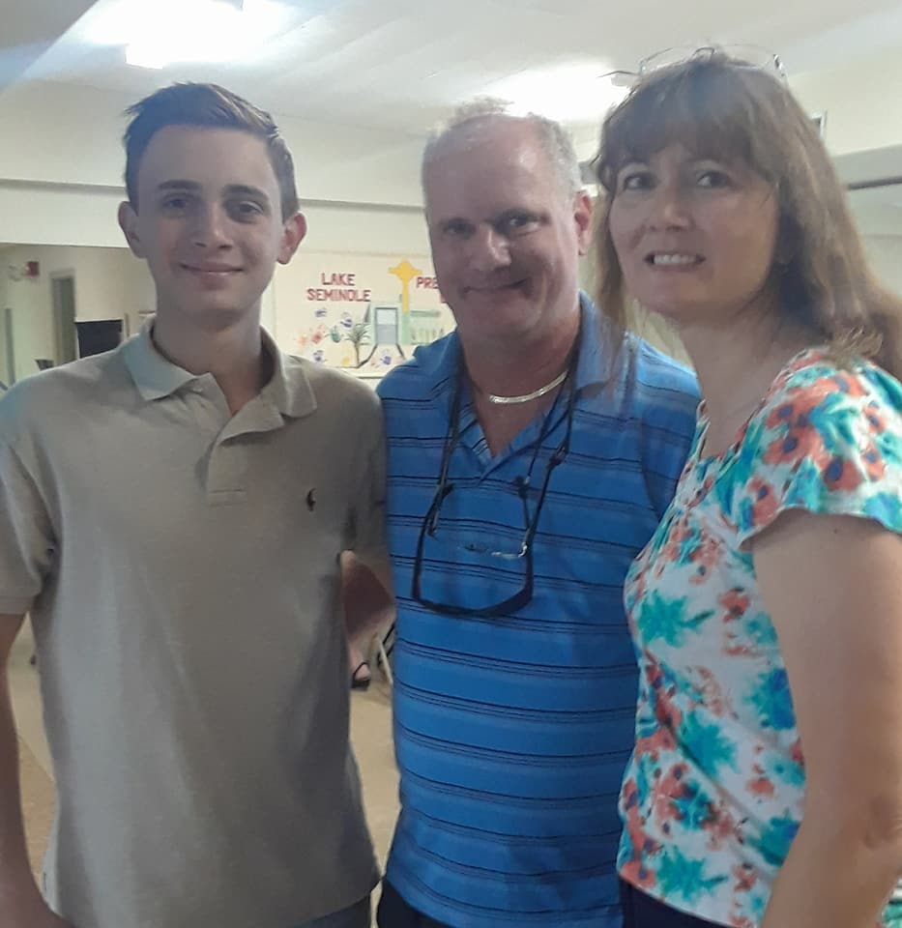
22nd Gordon Ollsen  27th Mariela  6961 Citrus Drive N.  Seminole, Florida 33772  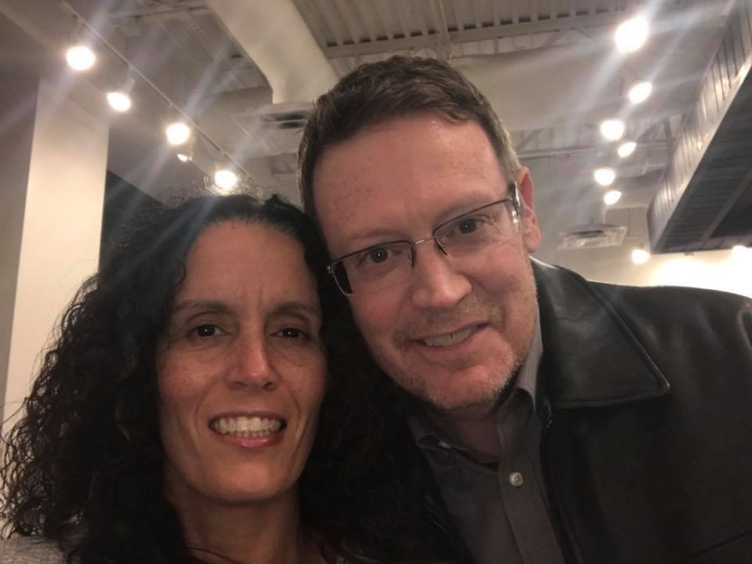 | 27th  Steve Anderson  8525 111th Street N #309  Seminole, Florida 33772   | 27th  Teresa Hehemann  8672 112th Street N.  Seminole, Florida 33772  

